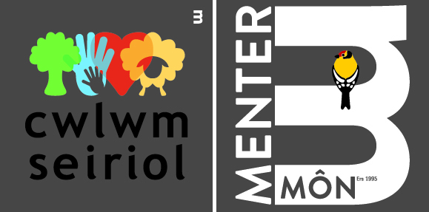


CREATE YOUR SPACE: CWLWM SEIRIOL PROJECT
PARTICIPANT’S REGISTRATION & EQUALITY MONITORING FORM

The Big Lottery want us to gather information about our project participants. This is to make sure that our activities are inclusive. Please be assured that all the information you provide will be treated in the strictest confidence and anonymised in reports to the Big Lottery. Thank you for your assistance.

NAME:

Address: ..........................................................................................................................................

….........................................................................................................Post Code ….......................

Telephone Number:..........................................................................................................................

Email Address:.................................................................................................................................

Access requirements / health conditions:
Do you have any access requirements or health conditions that we should know about?
 Yes  No
Please tell us more here (e.g. medications, allergies, etc.):

……………………………………………………………………………………………………………….

Emergency Contacts:
Please give us details of someone we could contact in case of an emergency.

Person 1,....................................................... Tel: ......................................................................

Person 2........................................................ Tel: ......................................................................

What types of activities are you interested in? (Tick all that apply)
Practical conservation tasks | □ | Walks and Talks | □
Outdoor Community Events e.g. litter picking | □ | Traditional Crafts e.g. whittling, hurdle making | □
Outdoor Learning activities e.g. Forest Schools | □ | Other: please specify □
Ecological Monitoring | □

What is your ethnic group? Choose one option that best describes your ethnic group or background
White | □ | Black/African/Caribbean/Black British | □
Mixed/Multiple ethnic groups | □ | Other ethnic group | □
Asian/Asian British | □ | Prefer not to say | □

Age
0-10 | □ | 11-15 | □ | 16-24 | □
25-34 | □ | 35-44 | □ | 45-54 | □
55-64 | □ | 65-74 | □ | 75+ | □
Prefer not to say |  | □

Gender
Male | □ | Female | □
Other | □ | Prefer not to say | □

Religion or belief
No religion | □ | Hindu | □
Christian | □ | Jewish | □
Muslim | □ | Other religion or belief | □
Prefer not to say |  | □

Which of the following best describes your ability in Welsh?
I’m fluent in Welsh | □
I can speak a fair amount of Welsh | □
I can only speak a little Welsh | □
I can only say just a few words | □
Prefer not to say | □

Do you consider yourself to be disabled?
Yes □ | No □ | Prefer not to say □

Do you consider yourself to be in ill health?
Yes □ | No □ | Prefer not to say □

If you are over 18, do you consider yourself unwaged?
Yes □ | No □ | Prefer not to say □

Sexual Orientation
Heterosexual | □ | Bisexual | □
Gay / Lesbian | □ | Prefer not to say | □

Privacy Notice
- Why we need your information
Cwlwm Seiriol officers will use your contact information to inform you about various opportunities arising under the project. For health and safety reasons we need to know about any relevant health conditions and the details of persons we should contact in case of an emergency. The data you supply will be entered into a spreadsheet and completed forms will kept securely.
- Justification for using your Information
We are using your information based on your consent.
- Sharing your information
The information you provide will not be shared with any organisations other than those directly involved with the delivery of the project.
- Automated Decision Making
The Cwlwm Seiriol project will not use your information for automated decision making or profiling.
- How long we keep your information and your rights
The information you supply will be kept securely until the end of the project (31/08/2023) or until you inform us that you no longer want us to retain the information in which case it will be deleted.
For further information about your rights and the Data Protection Officer’s contact details visit: https://www.mentermon.com/en/

For the purposes of compliance with the Data Protection Act 2018, I confirm that I give my consent for my information to be retained and used as described above.

Signed: …………………………………………………….… Date: ………………………………….

