Balchder Bro: Canllawiau
Balchder Bro: Guidelines

Cefndir
Background
Pwrpas rhaglen Balchder Bro yw meithrin balchder cymunedol drwy amryw weithgaredd. Nod y rhaglen yw cynnal a datblygu banc o gynlluniau ar lawr gwlad fydd yn cyfrannu’n helaeth at fwrlwm cymdeithasol, gwella iechyd a lles, a grymuso cymunedau a’r bobl sy’n byw ynddynt.
Byddwn yn gwneud hyn drwy wireddu ymyraethau a chynlluniau cynaliadwy o fewn y themâu canlynol:
1. Diwylliant a Threftadaeth
2. Asedau a Gwasanaethau Cymunedol
3. Cymunedau Carbon Isel
4. Amgylchedd a Bioamrywiaeth
Bydd Menter Môn yn gwireddu cynlluniau o fewn y themau hyn mewn amrywiol ffyrdd, gan gynnwys cydweithio â Chyngor Sir Ynys Môn i gwblhau elfennau o’r gwaith. Blaenoriaeth y rhaglen fydd sicrhau bod cymunedau’r Ynys yn ganolog i’r cynlluniau, ac felly bydd cyfle yma i gyd-gynllunio a chyd-wireddu gyda staff a phartneriaid.

The purpose of the Balchder Bro program is to foster community pride through various activities. The aim of the program is to maintain and develop a bank of activities across the island which will contribute greatly to social buzz, improve health and well-being, and empower communities and the people who live in them.
We will do this by implementing sustainable interventions and plans within the following themes:
- Culture and Heritage
- Community Assets and Services
- Low Carbon Communities
- Environment and Biodiversity
Menter Môn will realise plans within these themes in various ways, including collaboration with Anglesey County Council to complete elements of the work. The priority of the program will be to ensure that communities across the island are central to the plans, therefore there will be an opportunity here to co-plan and co-realise with staff and partners.

Pwrpas
Purpose
Mae Môn yn Ynys unigryw sy’n cynnwys pegynau o safbwynt iaith, daearyddiaeth, cymunedau trefol a gwledig, ac mae Menter Môn wedi gwireddu cynlluniau cymunedol ar draws y Sir ers 1996.
Bydd rhaglen Balchder Bro yn canolbwyntio yn bennaf ar Themâ 1 (Diwylliant a Threftadaeth ) ac yn cefnogi cymunedau i ddathlu’r hyn sy’n eu gwneud yn unigryw, yn gwarchod yr hyn sy’n eu gwneud yn arbennig, a hynny thrwy gefnogi gweithgarwch a digwyddiadau ar lawr gwlad yn ymarferol ac yn ariannol.
Mae’r cynllun yn caniatáu i Menter Môn a phartneriaid allweddol i ddefnyddio ein harbenigeddau a’u profiadau amgylcheddol, mentergarwch, technoleg, busnes, iaith ayyb i rymuso cymunedau ar draws y sir.
Ynys Môn is an unique island with a wide variation, from language to geography, urban to rural communitites, and Menter Môn has realised community plans across the County since 1996.
The Balchder Bro program will focus mainly on Theme 1, and support communities to celebrate what makes them unique, protect what makes them special, by supporting activity and events on the ground country practically and financially.

Amcanion
Objectives
Rydym yn croesawu syniadau gennych ar sut mae modd dathlu hunaniaeth eich cymuned chi trwy wahanol gynlluniau. Rydym am weld cynlluniau a syniadau creadigol, sy’n dangos Ynys Môn ar ei orau.
Disgwylir i bob prosiect gyrraedd o leiaf 3 o’r amcanion isod;
- Creu buddion cymunedol
- Meithrin yr iaith Gymraeg
- Dathlu adnoddau’r gymuned
- Datblygu cymeriad a hynodrwydd bro
- Cefnogi unrhyw fath o weithgaredd neu astudiaeth er budd y gymuned.

We welcome your ideas on how to celebrate your community’s identity through different schemes. We want to see creative plans and ideas, which show Anglesey at its best.
Each project is expected to fulfill at least 3 of the objectives below;
- Create community benefits
- Nurturing the Welsh language
- Celebrating the community’s resources
- Developing the character and distinctiveness of the community
- Support any type of activity or study for the benefit of the community.

Gweithgareddau Posib
Possible Activities
Isod cynigir rhai syniadau all eich cymuned ddatblygu er mwyn dathlu hunaniaeth lleol. Nid oes rheidrwydd i chi lynu at y math yma o ddigwyddiadau a gweithgareddau. Rydym yn pwysleisio ein bod yn croesawu creadigrwydd a syniadau newydd. Rydym eisiau clywed gennych chi fel cymuned a dysgu beth sy’n gwneud eich ardal chi’n arbennig.
Below are some ideas that your community can develop in order to celebrate local identity. You don’t necessarily have to stick to these types of events and activities. We emphasise that we welcome creativity and new ideas. We want to hear from you as a community and learn about what makes your area special.

Gweithgaredd  Activity | Eglurhad  Explanation
Celfi Môn (Gwaith celf sy’n ymwneud â hanes neu ddiwylliant eich cymuned)  Celfi Môn (Artwork involving your community's local history/heritage) | Gellid creu darnau o gelf gweledol yn eich cymuned trwy addurno wal, darn o adeilad, neu hyd yn oed safle bws. Oes darn o hanes werth ei drawsnewid yn gelf?  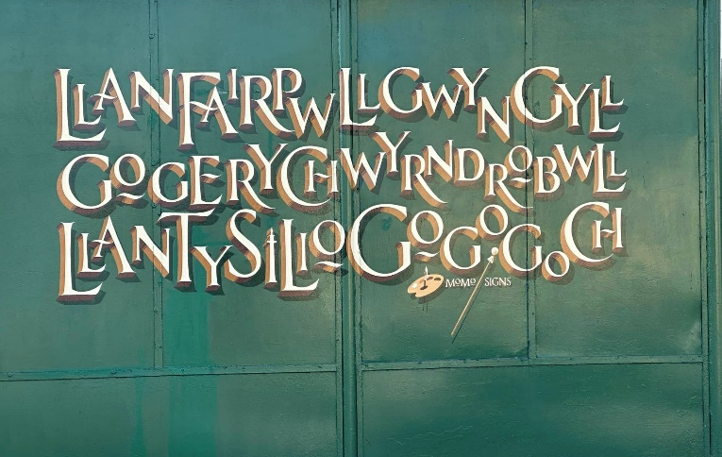  Pieces of visual art could be created in your community by decorating a wall, part of a building, or even a bus stop. Is there a piece of history worth turning into art?
Digwyddiad Cymunedol / Community event | Gall rhain fod yn ddigwyddiadau cymunedol amrywiol er mwyn dod a phobl ynghyd a chreu bwrlwm e.e. ffeiriau crefft, gwyliau cerddorol, gigs. Oes talent lleol y dylid ei ddathlu?  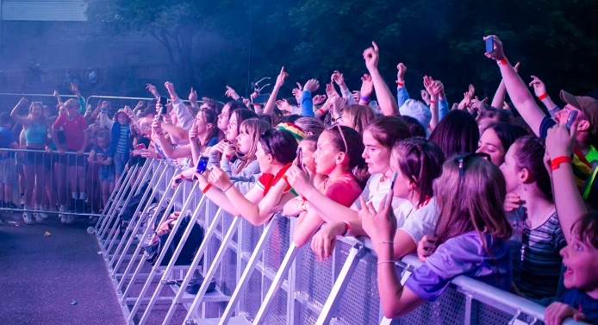  These can be various community events in order to bring people together and create buzz e.g. craft fairs, music festivals, gigs. Is there local talent that should be celebrated?
Digwyddiad Cymunedol i blant a theuluoedd / Family orientated avitivies | Beth am ddathlu traddodiad y Pasg ym Môn drwy glapio wyau? Neu gellid meddwl am ffyrdd newydd o ddathlu Calan Gaeaf neu’r Nadolig. Oes traddodiadau ym Môn na wyddwn ni amdanynt?  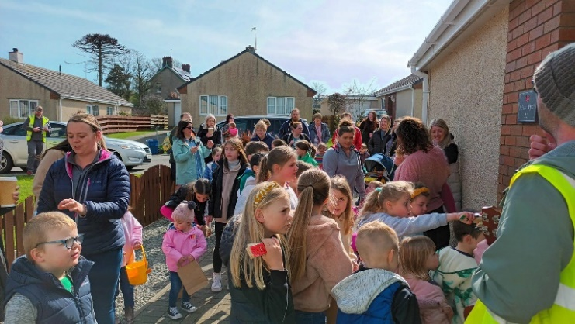  Why not celebrate the tradition of Easter in Anglesey by clapping eggs? Or think of new ways to celebrate Halloween or Christmas? Are there traditions in Anglesey that we don’t know about?
Gweithgareddau i Ddysgwyr / Activities for Welsh Language Learners | Mae cymaint o ffyrdd gwahanol i helpu siaradwyr newydd ddod yn rhan o’n cymunedau. Beth am ystyried gweithgareddau hwyliog e.e. sesiynau anffurfiol mewn caffis / tafarndai i gefnogi dysgwyr? Blasu’r Gymraeg drwy wahanol weithgareddau?  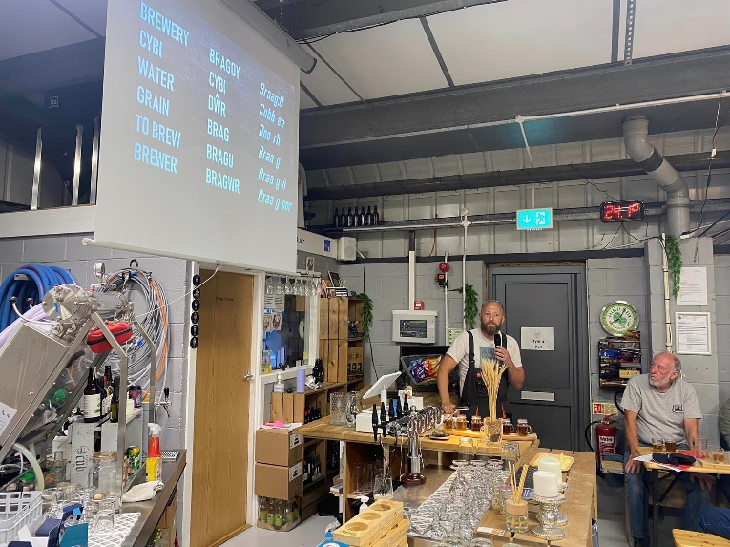  There are so many different ways to help new speakers become part of our communities. Why not consider fun activities e.g. informal sessions in cafes/ pubs to support learners? Taste the Welsh Language through different activities?
Deunyddiau gweledol i ddathlu hunaniaeth a/neu hyrwyddo’r Gymraeg e.e. arwyddion dwyieithog, ysgrifennu amlwg ayb / Visual materials to celebrate local identity or to promote the Welsh language e.g. Bilingual signs, obvious bilingual writing etc | Sut fyddech chi’n datblygu hunaniaeth mewn ffordd weledol? Oes ffordd o hyrwyddo’r Gymraeg yr un pryd? Beth am ystyried arwyddion dwyieithog, deunyddiau cymunedol ayb?  How would you develop an identity in a visual way? Is there a way to promote the Welsh Language at the same time? Why not consider bilingual signs, community materials etc?  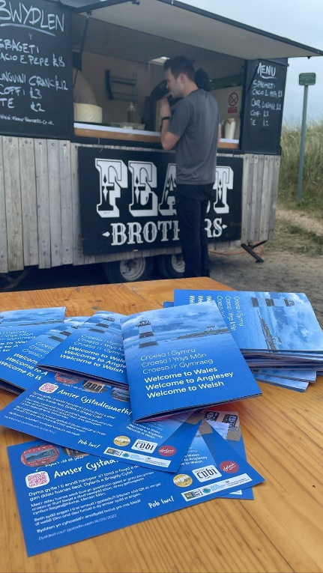
Harddu cymunedau e.e. potiau blodau, gwelliannau i fannau gwyrdd / Enriching communities e.g flower pots, developing green spaces | Gellir ystyried gwellau mannau cymunedol drwy ddatblygu mannau gwyrdd, neu gellid hyd yn oed ystyried cyfuno ymgais i hyrwyddo enw pentref neu ardal drwy harddu e.e. pot blodau mawr gyda enw’r pentref arno!  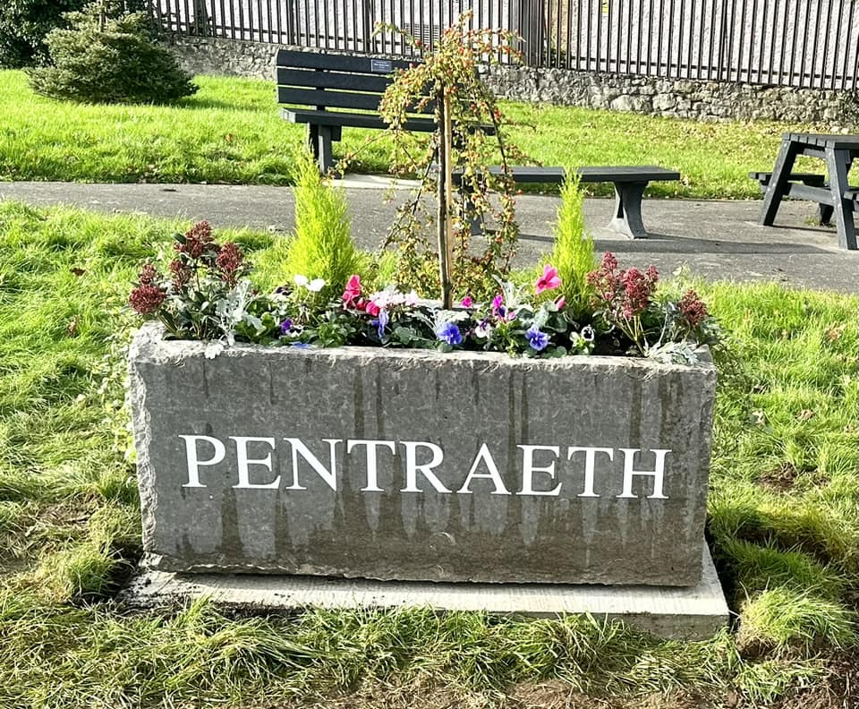  Improvements to community spaces could mean developing green spaces, or you could even consider combining an attempt to promote the name of a village or area by combining both aspects e.g. large flower pot with the name of the village on it!

Y broses ymgeisio
Application process
- Darllen y dogfennau canllawiau
- Trafod eich syniad gyda’r gymuned ehangach, neu/a gyda un o swyddogion Menter Môn Cyf (os yn berthnasol)
- Cwblhau’r ffurflen datgan diddordeb a’i gyflwyno i sionedmc@mentermon.com
Bydd modd i chi dderbyn cefnogaeth swyddogion Menter Môn Cyf. trwy gydol y broses ymgeisio i sicrhau bod eich cais mor gyflawn â phosib ar y pwynt yma. E-bostiwch cyfeiriad Sioned (uchod) os am sgwrs bellach cyn cyflwyno’r ffurflen hon.
Bydd y ffenest yma ar agor hyd at yr 18eg o Chwefror. Disgwylir i’r broses gyfan, o drafod eich prosiect i gymeradwyaeth, gymryd 3-6 wythnos.
*NODER – Bydd angen cwblhau pob prosiect yn llawn erbyn diwedd Medi 2024*

- Read the guidance documents
- Discuss your idea with the wider community, or/and with one of Menter Môn Cyf's officers (if needed)
- Complete the declaration of interest form and submit it to sionedmc@mentermon.com

Menter Môn Cyf’s officers support will be available throughout the application process to ensure your expression of interest is as detailed as possible. E-mail Sioned (address a
This window will be open until the 18th of February. The whole process, from discussing your project to approval, is expected to take 3-6 weeks.

*NOTE - all projects will need to be completed in full by the end of September 2024*

Gwybodaeth bellach ar / Further Information on;
Cronfa Ffyniant Gyffredin y DU
UK’s Shared Prosperity Fund

Mae’r Gronfa Ffyniant Gyffredin (Shared Prosperity Fund / SPF) yn rhan ganolog o agenda Hybu Ffyniant Bro Llywodraeth y DU. Mae’n darparu £2.6 biliwn o gyllid ar gyfer ei fuddsoddi’n lleol erbyn Mawrth 2025. Mae’r cyllid wedi ei rannu yn ôl yr Awdurdodau Lleol. Mae Ynys Môn wedi derbyn 16 miliwn o’r swm yma.

Nod y Gronfa yn gyffredinol yw gwella balchder mewn lle a chynyddu cyfleoedd bywyd ar draws y DU, buddsoddi mewn cymunedau a lle, gan gynorthwyo busnesau lleol, a phobl a sgiliau.

I gael rhagor o wybodaeth am SPF yn ei gyfanrwydd, ewch i https://www.gov.uk/government/publications/uk-shared-prosperity-fund-prospectus.cy

The Shared Prosperity Fund (SPF) is a central part of the UK Government’s Community Prosperity Promotion agenda. It provides £2.6 billion of funding for local investment by March 2025. The funding has been divided according to the Local Authorities. Anglesey has received 16 million of this sum.

The overall aim of the fund is to improve pride in place and increase life chances across the UK, investing in communities and place, supporting local buisnesses, and people and skills.

For more information, visit https://www.gov.uk/government/publications/uk-shared-prosperity-fund-prospectus.cy

